Modern Modular Laboratory V1.0

For Realistic view, as in its in screenshots you need to download **Legacy Cinematic Image Effects** from **Unity Technology**.   
We are using 4 effects that needs to be placed on Main Camera.

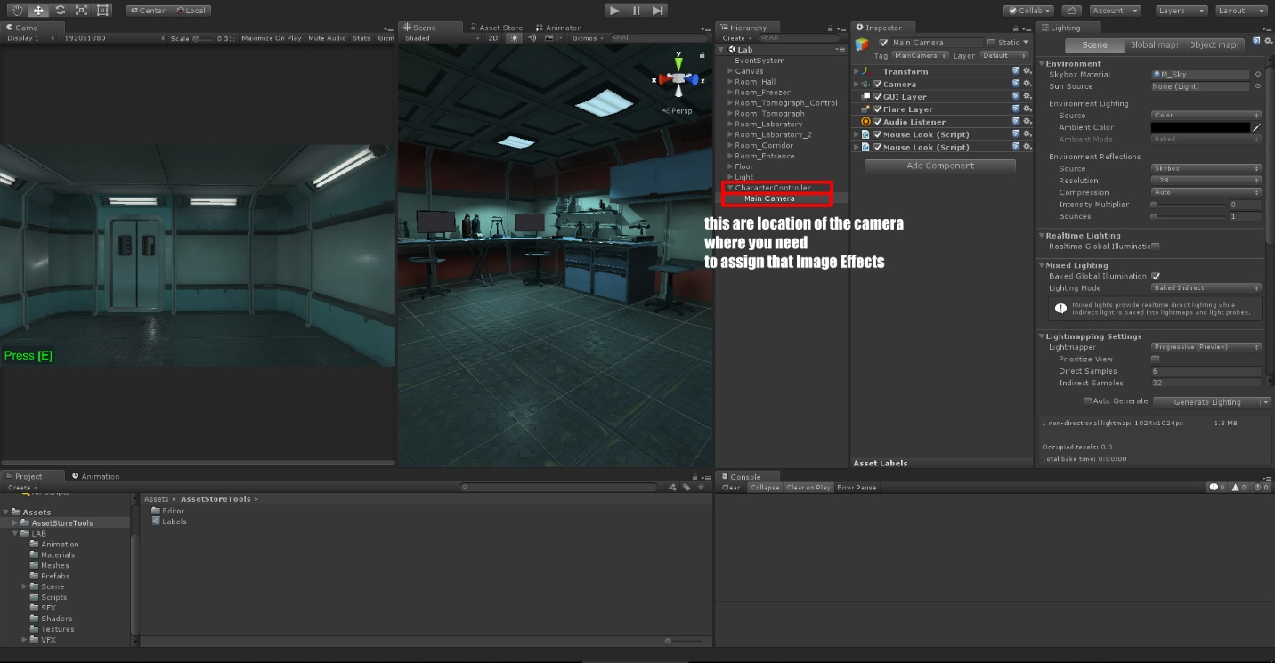

This are: **Ambient Occlusion, Bloom, Lens Aberrations and Tone Mapping Color Gradient.**

You need to set properties of this effects like in next screens to get the Magic Effect.

